Hypotalamus
Again these gods also personify the glands as well as the thalamus in the brain. Osiris representing the pineal gland; Isis representing the pituitary gland, and Horus representing the Thalamus centre of the brain – which to the ancients was the Third Eye. The popular "new-age" notion that the pineal gland represents the Third Eye is inaccurate. The Third Eye opens only when ‘conscious’ fusion takes place between the opposites. In terms of the brain these opposites are the essences relating to both the pineal and the pituitary glands.

Gary Osborn's Research, The Pyramid Code - Part 1. The Great Pyramid and the Sun-Earth-Moon System (Taken from The Real Stargate) www.gizapyramid.com...

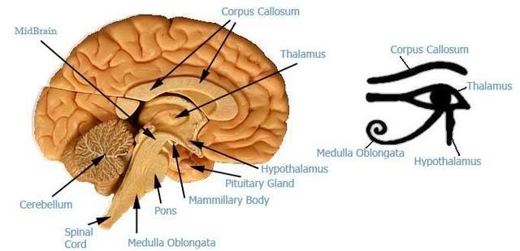

http://www.abovetopsecret.com/forum/thread296835/pg5%26mem=

